**CSE421 Project**

Group 22   
Project no: 2

ID: 17301108

ID: 17301124

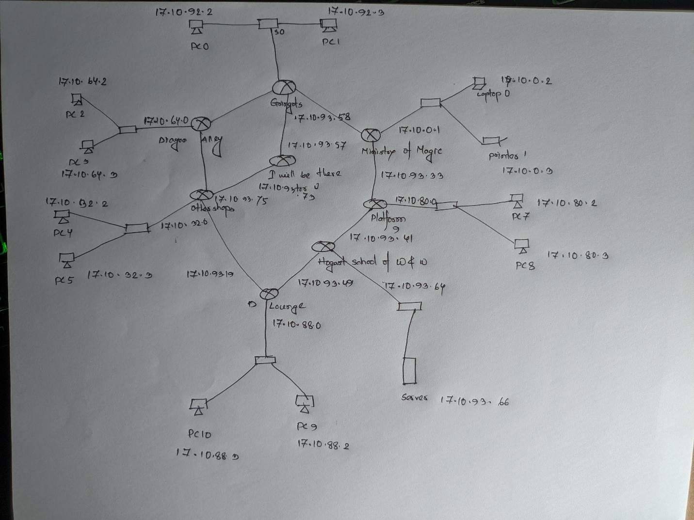

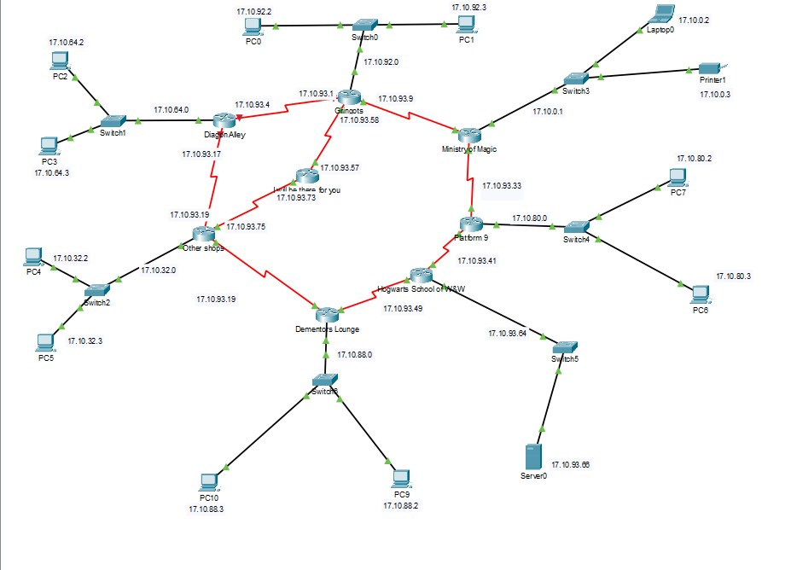

**Configuration:**

**Gringotts:**

Router>enable

Router#

Router# configure terminal

Router(config)#interface FastEthernet0/0

Router(config-if)#ip address 17.10.92.1 255.255.255.0

Router(config-if)#no shutdown

Router(config-if)#exit

Router(config)#interface Serial2/0

Router(config-if)#ip address 17.10.93.1 255.255.255.248

Router(config-if)#no shutdown

Router(config-if)#exit

Router(config)#interface Serial3/0

Router(config-if)ip address 17.10.93.9 255.255.255.248

Router(config-if)#no shutdown

Router(config-if)#exit

Router(config)#ip route 17.10.64.0 255.255.240.0 17.10.93.4

Router(config)#ip route 17.10.32.0 255.255.224.0 17.10.93.4

Router(config)#ip route 17.10.0.0 255.255.224.0 17.10.93.11

Router(config)#ip route 17.10.80.0 255.255.248.0 17.10.93.11

Router(config)#ip route 17.10.93.64 255.255.255.248 17.10.93.11

Router(config)#ip route 17.10.88.0 255.255.252.0 17.10.93.11

**Diagon Alley:**

Router(config)#ip route 17.10.32.0 255.255.224.0 17.10.93.19

Router(config)#ip route 17.10.92.0 255.255.255.0 17.10.93.1

Router(config)#ip route 17.10.0.0 255.255.224.0 17.10.93.1

Router(config)#ip route 17.10.80.0 255.255.248.0 17.10.93.1

Router(config)#ip route 17.10.93.64 255.255.255.248 17.10.93.1

Router(config)#ip route 17.10.88.0 255.255.252.0 17.10.93.1

**Others Shop:**

Router(config)#ip route 17.10.92.0 255.255.255.0 17.10.93.17

Router(config)#ip route 17.10.64.0 255.255.240.0 17.10.93.17

Router(config)#ip route 17.10.0.0 255.255.224.0 17.10.93.17

Router(config)#ip route 17.10.80.0 255.255.248.0 17.10.93.17

Router(config)#ip route 17.10.93.64 255.255.255.248 17.10.93.17

Router(config)#ip route 17.10.88.0 255.255.252.0 17.10.93.17

**Backup route (I will be there for you):**

Router(config)#ip route 17.10.32.0 255.255.224.0 17.10.93.75 5

Router(config)#ip route 17.10.92.0 255.255.255.0 17.10.93.58 5

Router(config)#ip route 17.10.0.0 255.255.224.0 17.10.93.58

Router(config)#ip route 17.10.80.0 255.255.248.0 17.10.93.58

Router(config)#ip route 17.10.93.64 255.255.255.248 17.10.93.58

Router(config)#ip route 17.10.88.0 255.255.252.0 17.10.93.58

**Dynamic**

**Ministry of Magic**

Router>enable

Router#

Router#configure terminal

Router(config)#interface FastEthernet0/0

Router(config-if)#ip address 17.10.0.1 255.255.224.0

Router(config-if)#no shutdown

Router(config-if)#exit

Router(config)#interface Serial2/0

Router(config-if)#ip address 17.10.93.11 255.255.255.248

Router(config-if)#no shutdown

Router(config-if)#exit

Router(config)#interface Serial3/0

Router(config-if)ip address 17.10.93.33 255.255.255.248

Router(config-if)#no shutdown

Router(config-if)#exit

Router(config)#router rip

Router(config-router)#version 2

Router(config-router)#no auto-summary

Router(config-router)#network 17.10.0.0

Router(config-router)#network 17.10.93.8

Router(config-router)#network 17.10.93.32

Router(config-router)#redistribute static

Router(config-router)#exit

Router(config)#ip route 17.10.92.0 255.255.255.0 17.10.93.9

Router(config)#ip route 17.10.64.0 255.255.240.0 17.10.93.9

Router(config)#ip route 17.10.32.0 255.255.224.0 17.10.93.9

Router(config)#exit

**Platform 9**

Router(config)#router rip

Router(config-router)#version 2

Router(config-router)#no auto-summary

Router(config-router)#network 17.10.80.0

Router(config-router)#network 17.10.93.32

Router(config-router)#network 17.10.93.40

Router(config-router)#redistribute static

Router(config-router)#exit

**Hogwarts School of Witchcraft and Wizardry**

Router(config)#router rip

Router(config-router)#version 2

Router(config-router)#no auto-summary

Router(config-router)#network 17.10.93.64

Router(config-router)#network 17.10.93.48

Router(config-router)#network 17.10.93.64

Router(config-router)#redistribute static

Router(config-router)#

**Dementors Lounge**

Router(config)#router rip

Router(config-router)#version 2

Router(config-router)#no auto-summary

Router(config-router)#network 17.10.88.0

Router(config-router)#network 17.10.93.24

Router(config-router)#network 17.10.93.48

Router(config-router)#redistribute static

Router(config-router)#end

Router#

Ministry of Magic (6546) 6548

Other shops (4565) 4567

Diagon Alley (3000) 3002

Platform 9 ¾ (1236) 1238

Dementors Lounge (756) 758

Gringotts (200) 202

Hogwarts School of Witchcraft and Wizardry (1) 3

Inter- router (18) 32

Total 16,350

17.10.0.0/17 has 131072 hosts

Subnet need 16350 hosts

|  |  |  |  |
| --- | --- | --- | --- |
| Name | Network Address | Slash | Mask |
| Ministry of Magic | 17.10.0.0 | /19 | 255.255.224.0 |
| Other shops | 17.10.32.0 | /19 | 255.255.224.0 |
| Diagon Alley | 17.10.64.0 | /20 | 255.255.240.0 |
| Platform 9 | 17.10.80.0 | /21 | 255.255.248.0 |
| Dementors Lounge | 17.10.88.0 | /22 | 255.255.252.0 |
| Gringots | 17.10.92.0 | /24 | 255.255.255.0 |
| Gringots -  Diagon Alley | 17.10.93.0 | /29 | 255.255.255.248 |
| Gringots - Ministry of Magic | 17.10.93.8 | /29 | 255.255.255.248 |
| Diagon Alley - Others shop | 17.10.93.16 | /29 | 255.255.255.248 |
| Others shop - Dementors Lounge | 17.10.93.24 | /29 | 255.255.255.248 |
| Ministry of Magic - Platform 9 | 17.10.93.32 | /29 | 255.255.255.248 |
| Platform 9 - Hogwarts School of Witchcraft and Wizardry | 17.10.93.40 | /29 | 255.255.255.248 |
| Hogwarts School of Witchcraft and Wizardry - Dementors Lounge | 17.10.93.48 | /29 | 255.255.255.248 |
| Backup Router - Gringots | 17.10.93.56 | /29 | 255.255.255.248 |
| Hogwarts School of Witchcraft and Wizardry | 17.10.93.64 | /29 | 255.255.255.248 |
| Othershop - Backup Router | 17.10.93.72 | /29 | 255.255.255.248 |

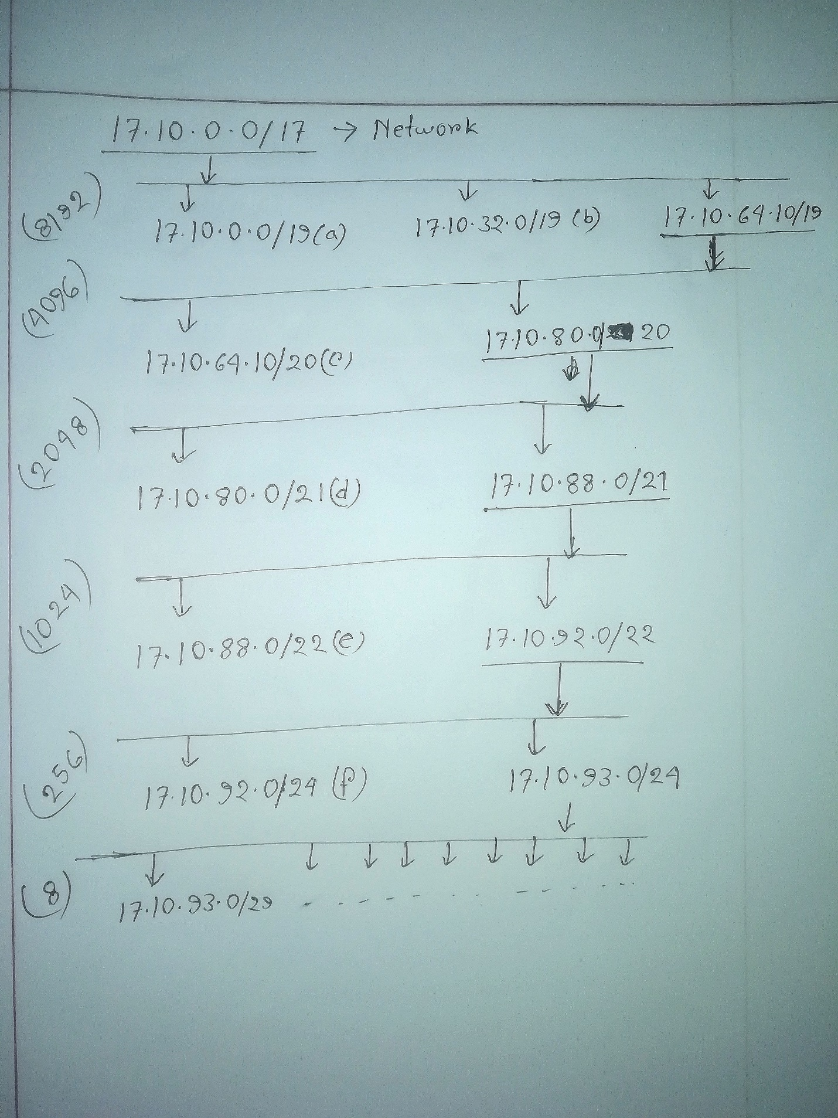

**Addressing Table**

|  |  |  |  |  |
| --- | --- | --- | --- | --- |
| **Device** | **Interface** | **IPV4 Address** | **Subnet Mask** | **Default Gateway** |
| **Gringotts** | F0/0 | 17.10.92.1 | 255.255.255.0 |  |
| S2/0 | 17.10.93.1 | 255.255.255.248 |  |
| S3/0 | 17.10.93.9 | 255.255.255.248 |  |
| S6/0 | 17.10.93.58 | 255.255.255.248 |  |
| **Diagon Alley** | F0/0 | 17.10.64.1 | 255.255.240.0 |  |
| S2/0 | 17.10.93.17 | 255.255.255.248 |  |
| S3/0 | 17.10.93.4 | 255.255.255.248 |  |
| **Others Shops** | F0/0 | 17.10.32.1 | 255.255.240.0 |  |
| S2/0 | 17.10.93.25 | 255.255.255.248 |  |
| S3/0 | 17.10.93.19 | 255.255.255.248 |  |
| S7/0 | 17.10.93.75 | 255.255.255.248 |  |
| **Dementors Lounge** | F0/0 | 17.10.88.1 | 255.255.252.0 |  |
| S2/0 | 17.10.93.51 | 255.255.255.248 |  |
| S3/0 | 17.10.93.27 | 255.255.255.248 |  |
| **Hogwarts School of W&W** | F0/0 | 17.10.93.65 | 255.255.255.248 |  |
| S2/0 | 17.10.93.43 | 255.255.255.248 |  |
| S3/0 | 17.10.93.49 | 255.255.255.248 |  |
| **Platform 9** | F0/0 | 17.10.80.1 | 255.255.248.0 |  |
| S2/0 | 17.10.93.35 | 255.255.255.248 |  |
| S3/0 | 17.10.93.41 | 255.255.255.248 |  |
| **Ministry of Magic** | F0/0 | 17.10.0.0 | 255.255.224.0 |  |
| S2/0 | 17.10.93.11 | 255.255.255.248 |  |
| S3/0 | 17.10.93.33 | 255.255.255.248 |  |
| **I will be there for you** | S2/0 | 17.10.93.57 | 255.255.255.248 |  |
| S3/0 | 17.10.93.73 | 255.255.255.248 |  |
| **PC0** | NIC | 17.10.92.2 | 255.255.255.0 | 17.10.92.1 |
| **PC1** | NIC | 17.10.92.3 | 255.255.255.0 | 17.10.92.1 |
| **PC2** | NIC | 17.10.64.2 | 255.255.240.0 | 17.10.64.1 |
| **PC3** | NIC | 17.10.64.3 | 255.255.240.0 | 17.10.64.1 |
| **PC4** | NIC | 17.10.32.2 | 255.255.240.0 | 17.10.32.1 |
| **PC5** | NIC | 17.10.32.3 | 255.255.240.0 | 17.10.32.1 |
| **PC6** | NIC | 17.10.80.3 | 255.255.248.0 | 17.10.80.1 |
| **PC7** | NIC | 17.10.80.2 | 255.255.248.0 | 17.10.80.1 |
| **PC9** | NIC | 17.10.88.2 | 255.255.248.0 | 17.10.88.1 |
| **PC10** | NIC | 17.10.88.3 | 255.255.248.0 | 17.10.88.1 |
| **Printer1** | NIC | 17.10.0.3 | 255.255.224.0 | 17.10.10.1 |
| **Laptop0** | NIC | 17.10.0.2 | 255.255.224.0 | 17.10.10.1 |
| **Server** | NIC | 17.10.93.66 | 255.255.255.248 | 17.10.93.65 |